**PIZZA SALES SQL QUERIES**

**A. KPIS :**

**TOTAL REVENUE**

SELECT SUM(total_price) AS total_revenue FROM pizza_sales;

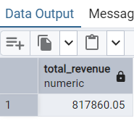

**2 AVERAGE ORDER VALUE**

SELECT SUM(total_price)/ COUNT(DISTINCT order_id) AS avg_order_value FROM pizza_sales

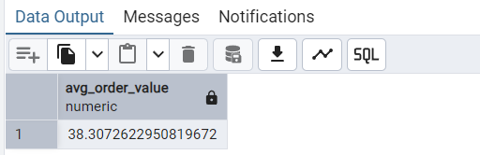

**3 TOTAL PIZZA SOLD**

SELECT SUM(quantity) AS total_pizza_sold FROM pizza_sales;

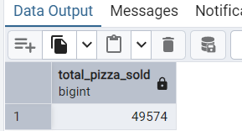

**4 . TOTAL ORDERS**

SELECT COUNT(DISTINCT order_id)AS Total_orders FROM pizza_sales;

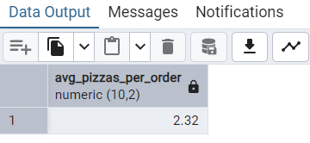

**5 AVERAGE PIZZA PER ORDERS**

SELECT CAST(CAST(SUM(quantity) AS DECIMAL(10,2)) /

CAST(COUNT(DISTINCT order_id) AS DECIMAL(10,2)) AS DECIMAL(10,2))

AS Avg_Pizzas_per_order

FROM pizza_sales;



**B. Daily Trend for Total Orders**

SELECT TO_CHAR(order_date, 'Day') AS order_day,

COUNT(DISTINCT order_id) AS total_orders

FROM pizza_sales

GROUP BY order_day, EXTRACT(DOW FROM order_date)

ORDER BY EXTRACT(DOW FROM order_date);

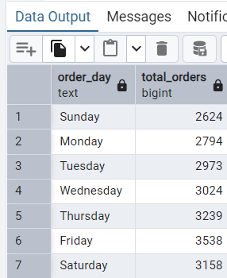

**C. MONTHLY TREND FOR TOTAL ORDERS**

SELECT TO_CHAR(order_date, 'Month') AS month_name,

COUNT(DISTINCT order_id) AS total_orders

FROM pizza_sales

GROUP BY month_name, EXTRACT(MONTH FROM order_date)

ORDER BY EXTRACT(MONTH FROM order_date );

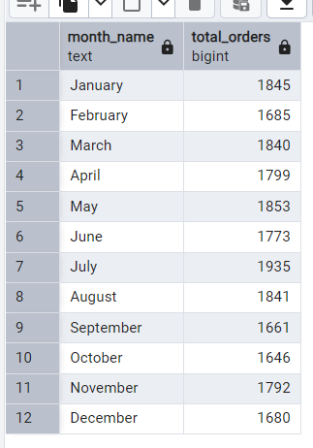

**D. % SALES BY PIZZA CATEGORY**

SELECT pizza_category, CAST(SUM(total_price) AS DECIMAL(10,2)) as total_sales,

CAST(SUM(total_price) * 100 / (SELECT SUM(total_price) from pizza_sales) AS DECIMAL(10,2)) AS PCT

FROM pizza_sales

GROUP BY pizza_category

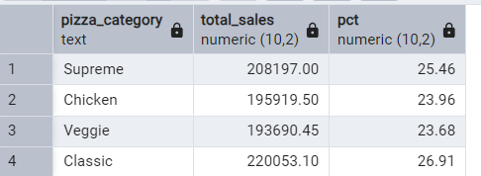

**E. % OF SALES BY PIZZA SIZE**

SELECT pizza_size, CAST(SUM(total_price) AS DECIMAL(10,2)) as total_sales,

CAST(SUM(total_price) * 100 / (SELECT SUM(total_price) from pizza_sales) AS DECIMAL(10,2)) AS PCT

FROM pizza_sales

GROUP BY pizza_size;

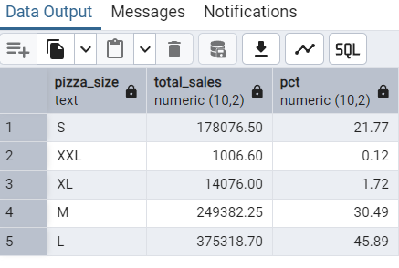

**F. TOTAL PIZZAS SOLD BY PIZZA CATEGORY**

SELECT pizza_category, SUM(quantity) AS total_quantity_sold

FROM pizza_sales

GROUP BY pizza_category

ORDER BY total_quantity_sold DESC;

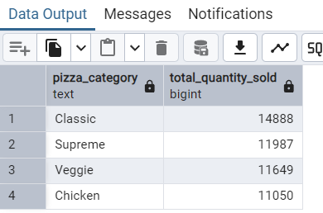

**G.TOP 5 PIZZAS BY REVENUE**

SELECT pizza_name , SUM(total_price) AS Total_revenue

FROM pizza_sales

GROUP BY pizza_name

ORDER BY total_revenue DESC

LIMIT 5;

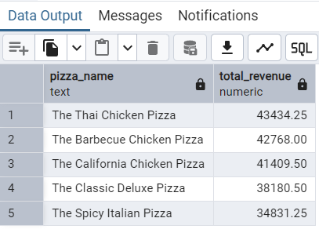

**H.BOTTOM 5 PIZZAS BY REVENUE**

SELECT pizza_name , SUM(total_price) AS Total_revenue

FROM pizza_sales

GROUP BY pizza_name

ORDER BY total_revenue ASC

LIMIT 5;

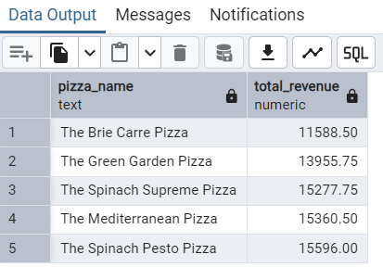

**I.TOP 5 PIZZA BY QUANITIY**

SELECT pizza_name , SUM(quantity) AS Total_pizza_sold

FROM pizza_sales

GROUP BY pizza_name

ORDER BY total_pizza_sold DESC

LIMIT 5;

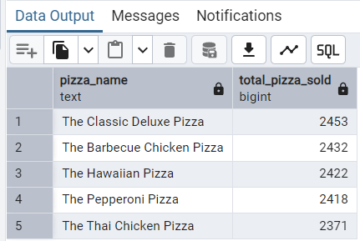

**J. BOTTOM 5 PIZZA BY QUANITIY**

SELECT pizza_name, sum(quantity) AS total_pizza_sold

FROM pizza_sales

GROUP BY pizza_name

ORDER BY total_pizza_sold ASC

LIMIT 5;

**K. TOP 5 PIZZAS BY TOTAL ORDERS**

SELECT pizza_name, COUNT(DISTINCT order_id) AS total_orders

FROM pizza_sales

GROUP BY pizza_name

ORDER BY total_orders DESC

LIMIT 5;

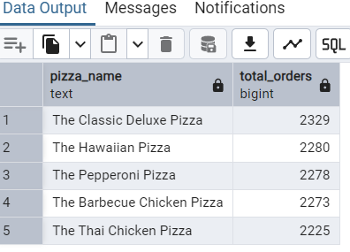

**L. BOTTOM 5 PIZZAS BY TOTAL ORDERS**

SELECT pizza_name, COUNT(DISTINCT order_id) AS total_orders

FROM pizza_sales

GROUP BY pizza_name

ORDER BY total_orders ASC

LIMIT 5;

